Syslog configuration
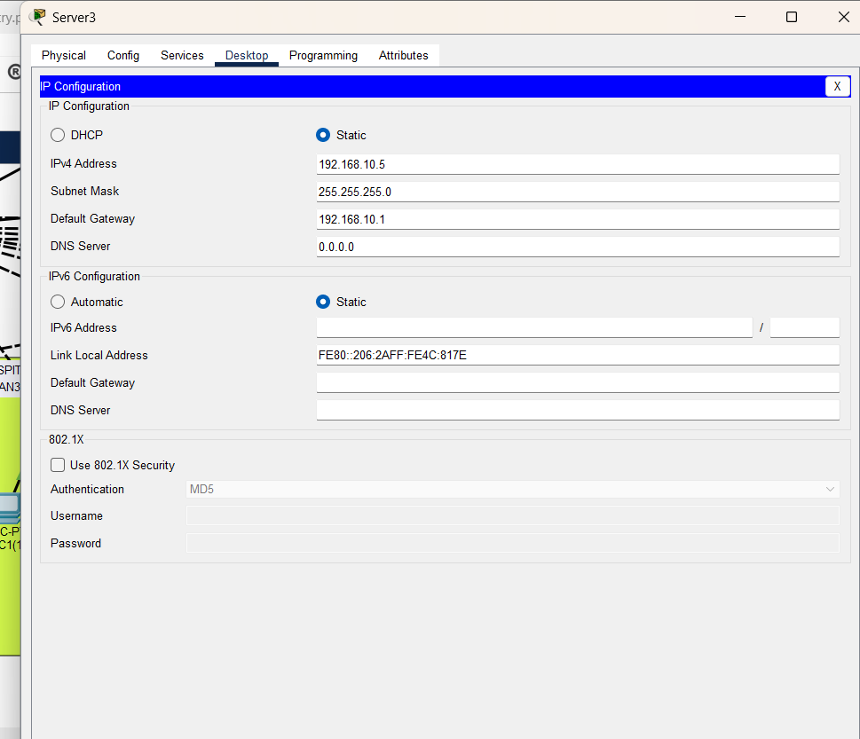
set an static ip as it’s a server,
follow that image ip scheme 192.168.10.5/24 where .1 is gateway,
Now navigate to services,
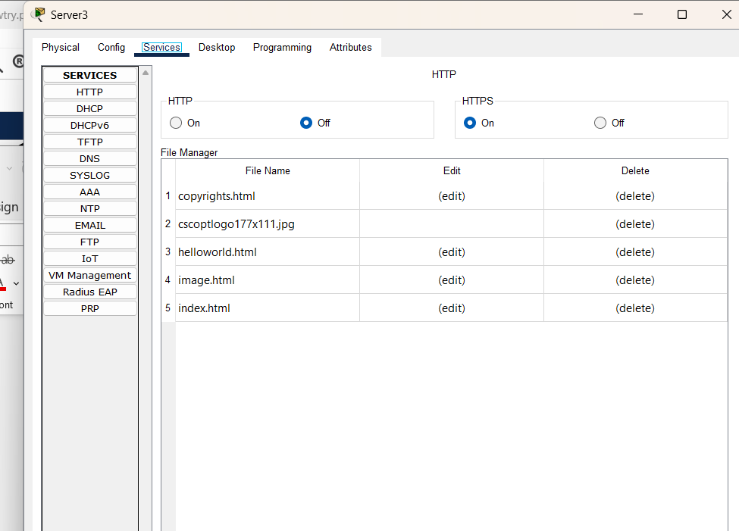
turn off http as it is insecure,
Now turn on syslog services,
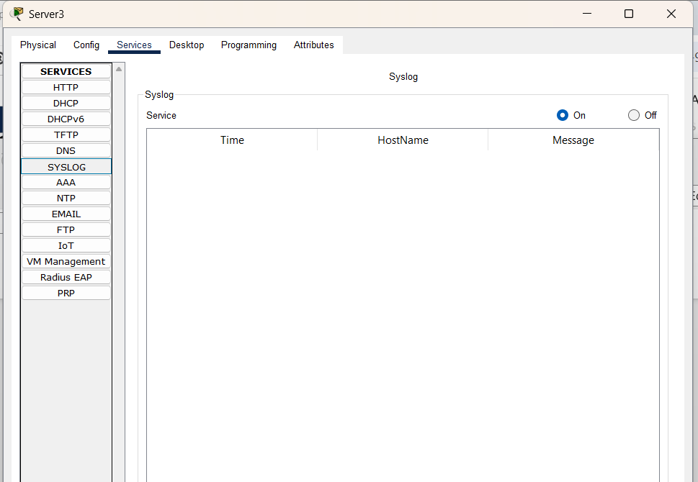
Now got to mls and type syslog config command in both mls as we have redundancy setup,
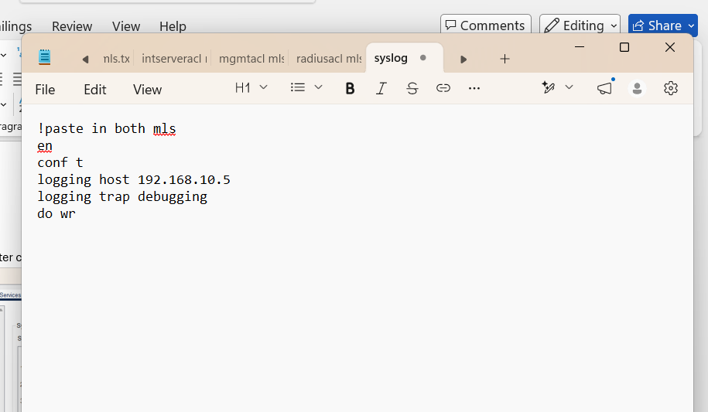
and see now after closing and reopening pkt tracer to see if it works or not,
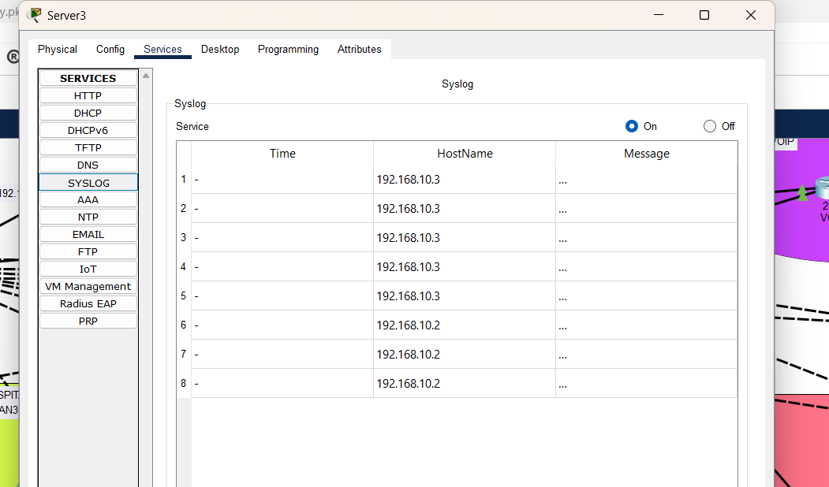
it worked.
Now https service turned on,
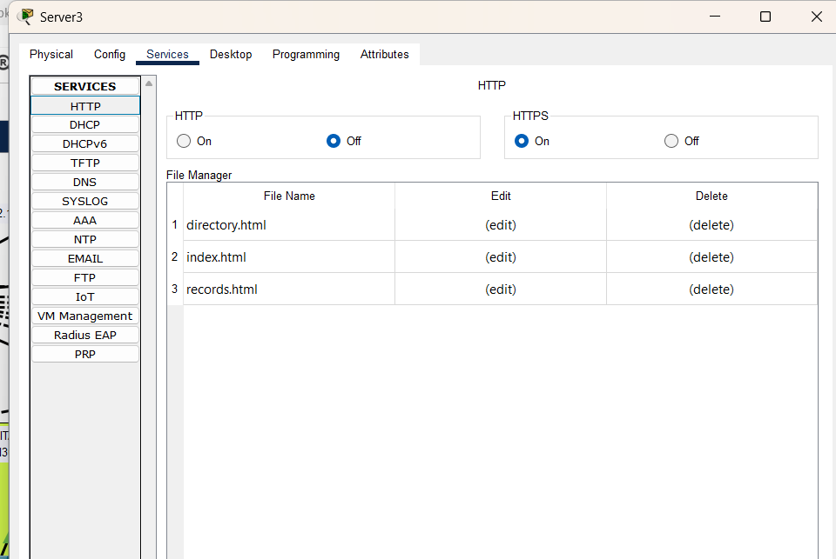
here I used ai to create simple sample for website so I deleted default and add on, import,
Now lets check this website from staff pc,
open browser type https://192.168.10.5 ,
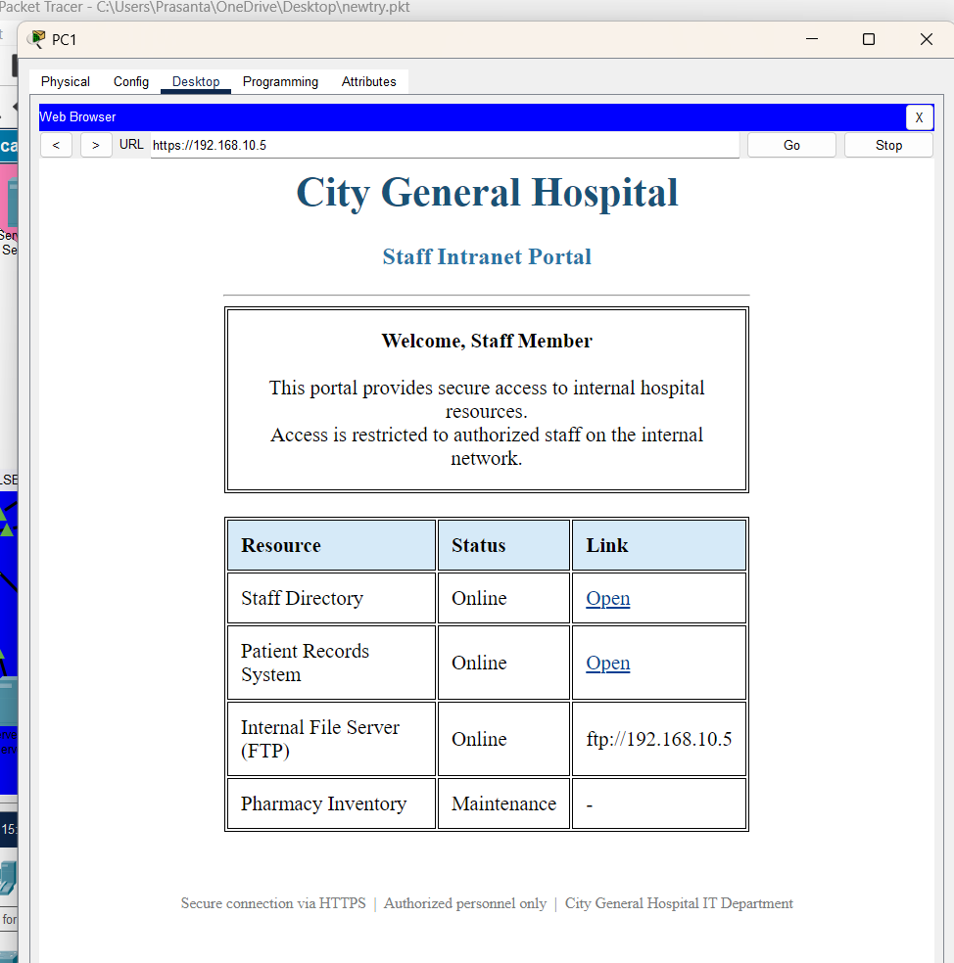
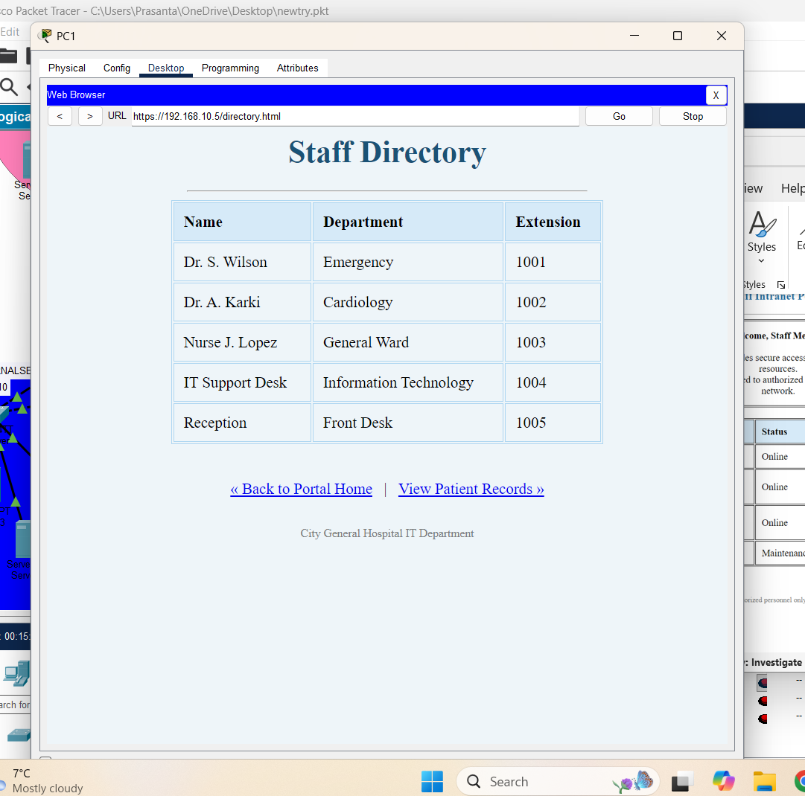
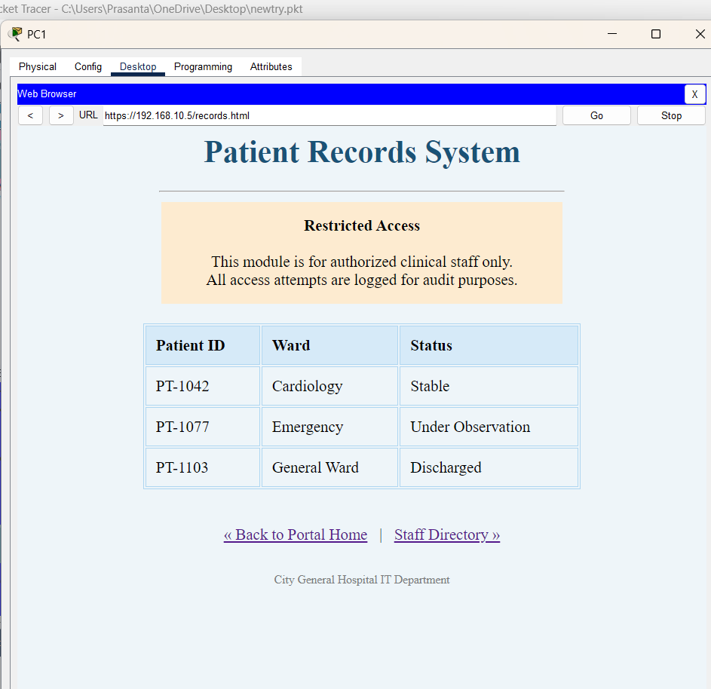
Now lets turn on ftp service and create username and password,
Here I am using ftp which is only possible but in real life we will be using more secure transfer protocol like SMB version 2 or similar,
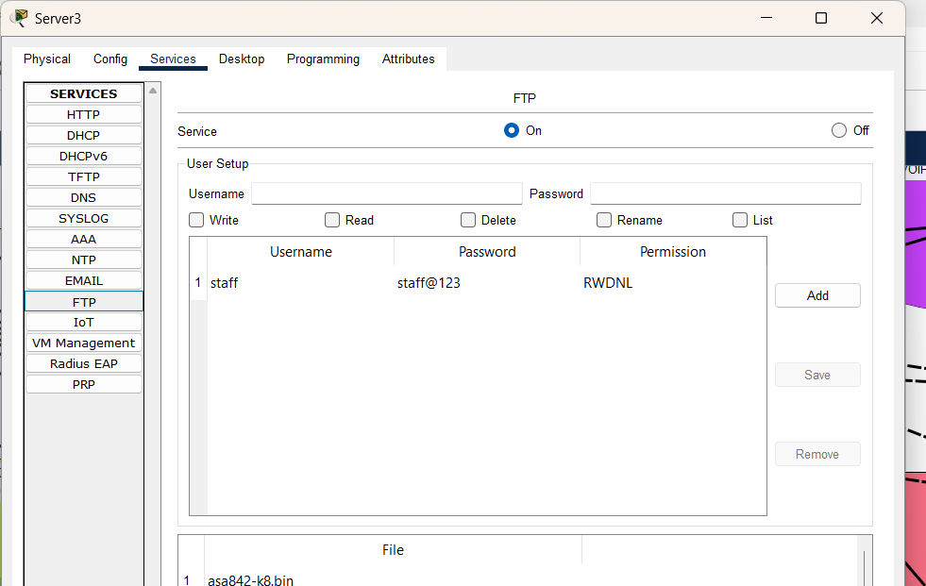
Now lets open ftp from staff pc
ftp 192.168.10.5
Navigate command prompt desktop in staff pc,
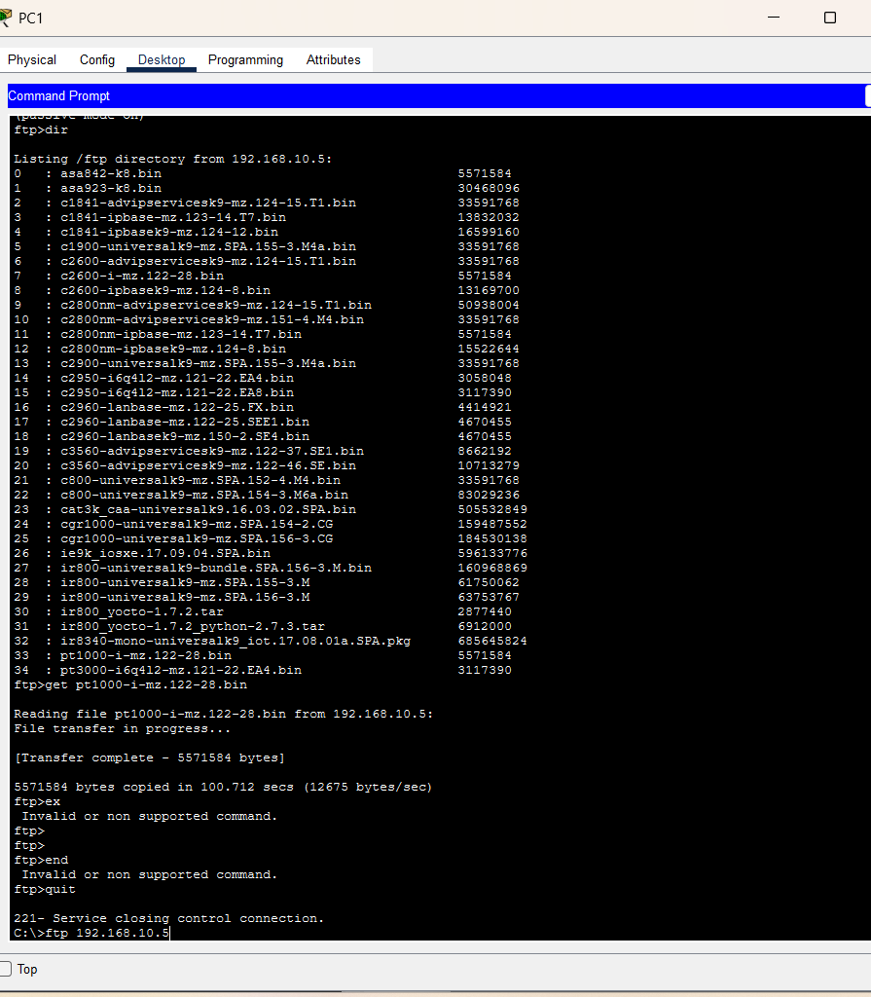
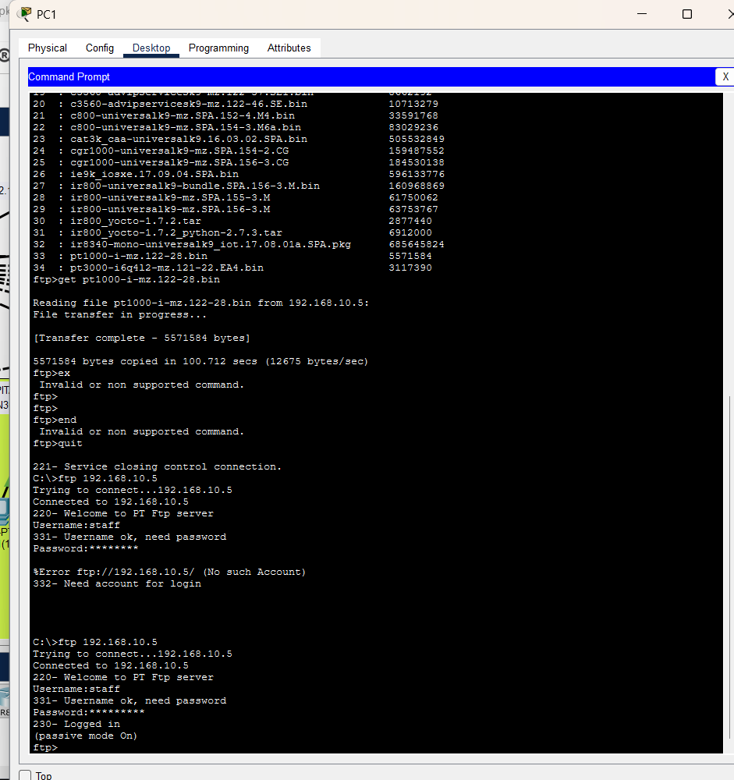
I logged in using username and password
lets see ftp directory of server,
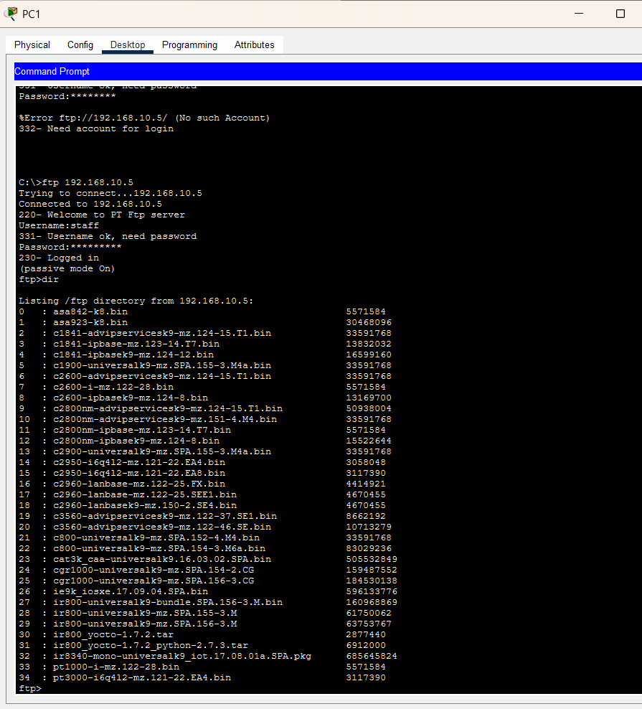
lets transfer file to ftp server from this desktop as we have sample file in tftp in staff pc,
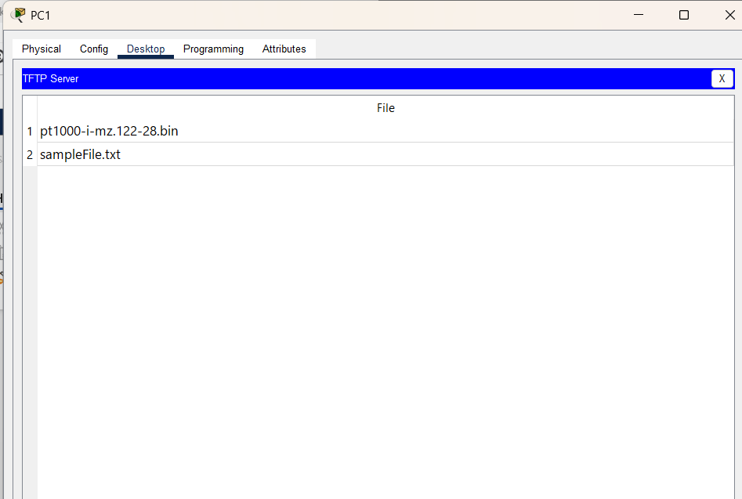
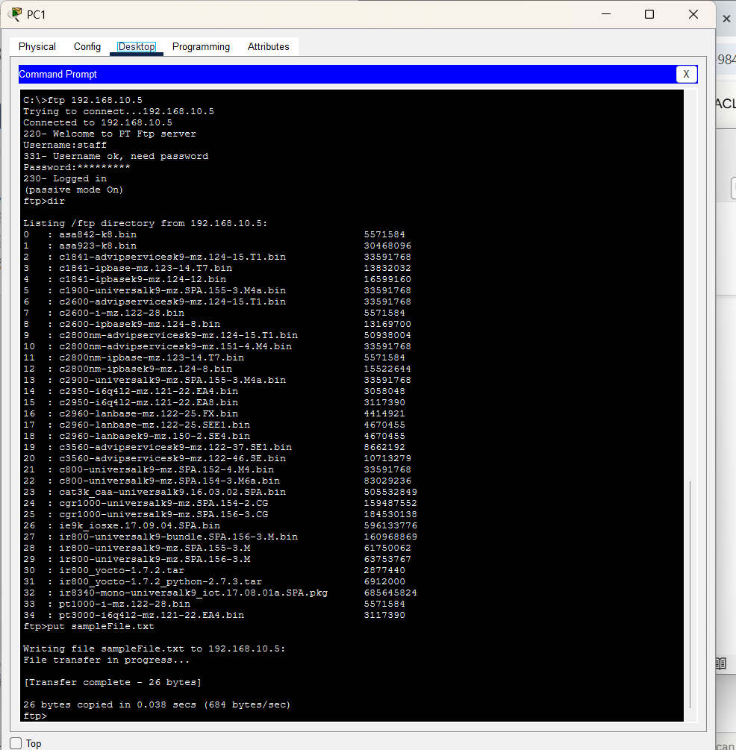
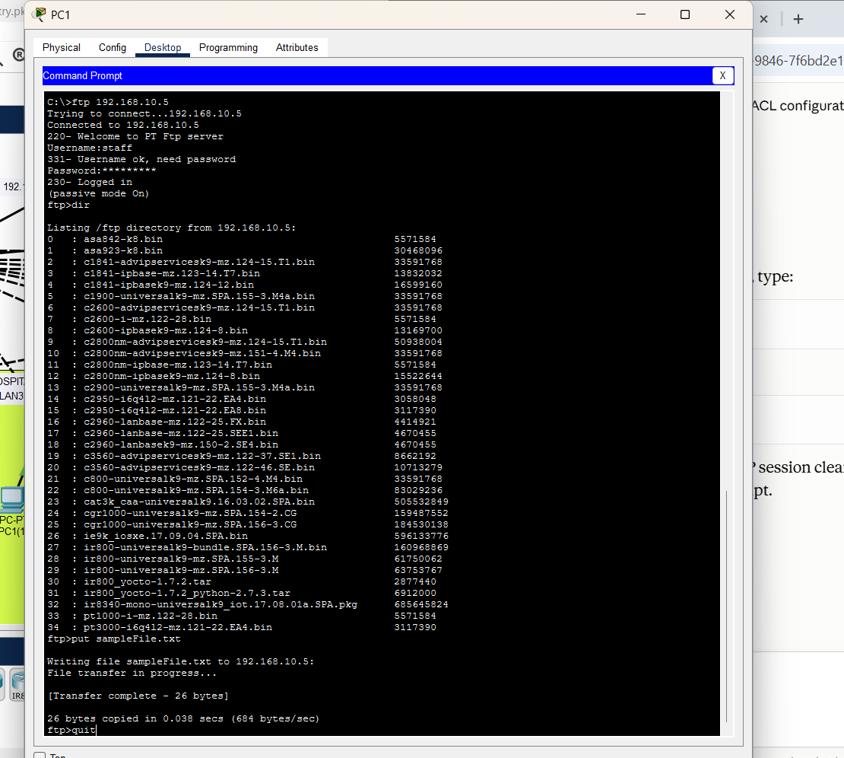
Now lets check in ftp server side,
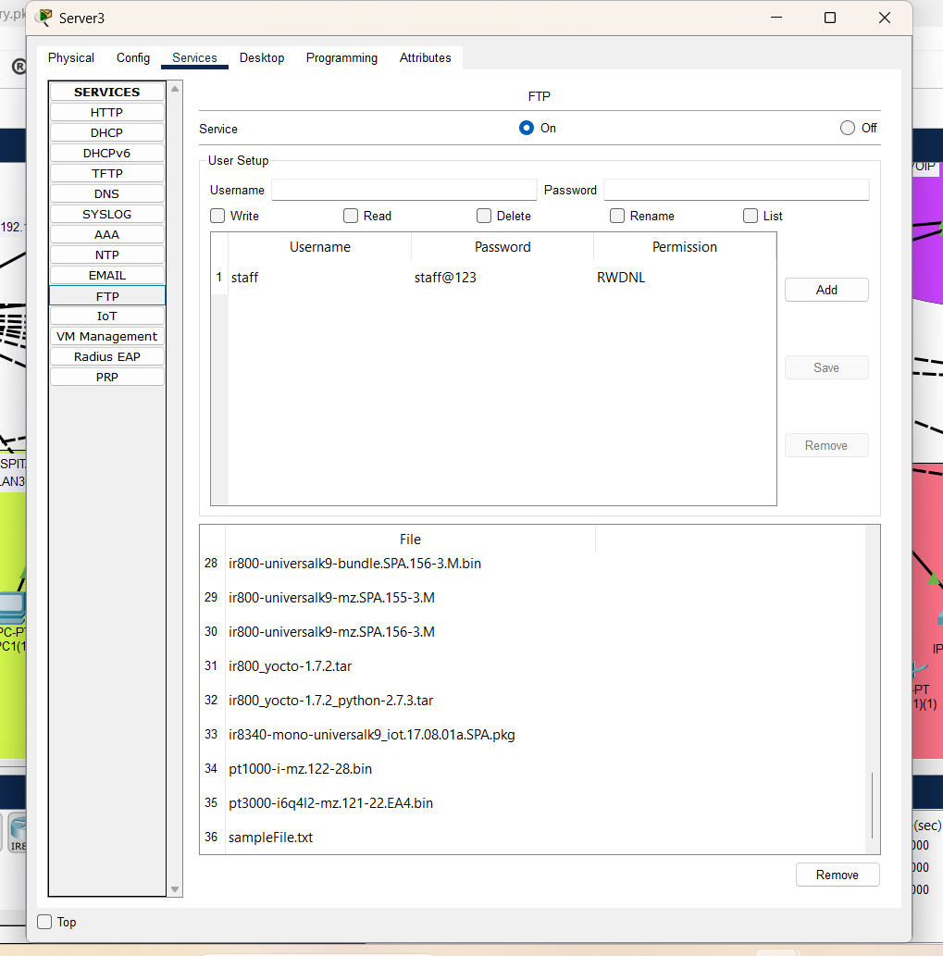
look file is trnsfered.
FTP service is running properly.

